**UPPER RIO GRANDE WATER OPERATIONS MODEL**

**URGWOM Expression Slot Functions Documentation**

**VOLUME 2c**

Version 9.3

September 26th, 2024

*Submitted to:*



U.S. Army Corps of Engineers

Albuquerque District

4101 Jefferson Plaza NE

Albuquerque, New Mexico 87109

*Prepared by:*

Tetra Tech, Inc.

6121 Indian School Road NE, Suite 205 Albuquerque, New Mexico 87110

Hydros Consulting

1628 Walnut Street Boulder, Colorado 80302

Page Intentionally Left Blank

# TABLE OF CONTENTS

TABLE OF CONTENTS iii

TABLE OF FIGURES v

TABLE OF TABLES v

Abbreviations and Acronyms Used v

Introduction 1

Expression Slot Functions 4

1. Account Lists 4

1.1. MakeSourceList 4

1.2. AllSJSuppliesFromAbiquiu 4

1.3. AllSJSuppliesFromElVado 5

1.4. ContractorSuppliesIntoReservoir 6

1.5. ContractorSuppliesFromReservoir 6

2. Account Summing Functions 7

2.1. SumAccountStorageAtGivenDate 7

2.2. SumAccountStorage 7

2.3. SumSupplies 8

2.4. SumSuppliesAtPreviousTimestep 8

2.5. SumSuppliesSlot 9

3. Date Functions 10

3.1. StartOfMonthOrRun 10

3.2. EndOfPreviousMonth 10

3.3. DateOfStartRow 11

3.4. RowOfGivenDateInTableSeries 12

3.5. AbbreviateMonth 12

3.6. Add0ToDay 14

3.7. GetStartDate 15

3.8. DatePlusTime 16

3.9. EndOfPrevYear 16

3.10. FirstTimestepOfMonth 16

3.11. IsFirstTimestepOfMonth 17

4. General Account Functions 17

4.1. AccountStorageAtGivenDate 17

4.2. PreviousAccountStorage 18

5. General Boolean Functions 18

5.1. NaNInSlot 18

5.2. NaNInTableSeriesSlot 19

5.3. IsIterativeRun 20

5.4. IsAOPModelRun 20

5.5. IsAccountModelRun 20

5.6. IsHistoricalModelRun 21

5.7. IsIrrigationSeasonCO 21

5.8. IsFirstTimestepCOIrrigationSeason 21

6. Get Data Functions 22

6.1. RoundingFactorVolume 22

6.2. RoundVolume 23

6.3. CurrentStorage 24

6.4. SJCLoss 24

6.5. PreviousStorage 24

6.6. HydrologyYearType 25

6.7. GetTableDate 25

6.8. IceMonths 26

6.9. GetNRCSForecast 26

6.10. GetWholeNumberAsString 27

6.11. GetMRGCDDiversionRequested 27

6.12. MinTargetFlowWithoutSafetyFactor 28

6.13. Round 29

7. Summing Functions 29

7.1. SumTableSeriesSlotByColumn 29

7.2. SumDiversionReachDepletionsToVolume 30

8. TimestepFunctions 31

8.1. DatePlusNTimesteps 31

8.2. FirstTimestepOfYear 32

8.3. IsFirstTimestepOfYear 32

8.4. RoundDateToTimestepEnd 33

8.5. RoundDurationToTimestep 33

# TABLE OF FIGURES

Figure 1. Screen capture of the URGWOM workspace showing some of the data objects used for reporting 2

# TABLE OF TABLES

Table 1. Data Objects Referenced by the DMI "OutputAccountingToUCHDB2" 3

Table 2. Expression Slot Function Groups 4

# Abbreviations and Acronyms Used

AOP Annual Operating Plan

CADSWES Center for Advanced Decision Support for Water and Environmental Systems

DMI Data Management Interface

RGCC Rio Grande Compact Commission

RPL Riverware Policy Language

URGWOM Upper Rio Grande Water Operations Model

USBR United States Bureau of Reclamation

# Introduction

URGWOM (The Upper Rio Grande Water Operations Model) was developed with the RiverWare software application developed at the Center for Advanced Decision Support for Water and Environmental Systems (CADSWES) at the University of Colorado at Boulder. The model is a daily or monthly timestep model for simulating operations of facilities and diversions along the Rio Grande and major tributaries within Colorado, New Mexico, Texas, and Mexico. For more information on the model the reader is referred to Volume 1 of the URGWOM documentation which describes the physical model.

This document serves as a reference for users working on Expression Slot Functions in URGWOM. Other URGWOM Documentation volumes cover such topics as Accounting Concepts and Methods, Physical Processes, Initialization ruleset, and other features developed to setup and run the model. The URGWOM Documentation volumes are listed below:

**Volume 1: Physical Documentation**

**Volume 2a: Policy Rules Documentation**

**Volume 2b: Initialization Rules Documentation**

**Volume 2c: Expression Slot Functions Documentation**

**Volume 3: Accounting Concepts and Methods**

**Volume 4: Database Documentation**

**Volume 5: DMI and SCT Documentation**

**Volume 6: User's Manual (Script Documentation)**

Expression slots are user-defined slots in a model object whose value is computed from a user-defined arithmetic expression. Expressions are developed using the RiverWare Policy Language (RPL) similar to Operational Policy and Initialization rules. Within URGWOM, expression slots exist in 84 different data objects and are used to summarize or aggregate output data during, or at the completion of, a model run. The data objects are associated with a range of model aspects including reach flows, reservoir operations, diversion calculations and contractor accounting. The majority of these objects are associated with US Bureau of Reclamation (USBR) San Juan - Chama Project accounting and are organized in the model workspace to the left of the Middle Valley section of the model (**Figure 1**). These objects summarize reservoir, weather and contractor delivery data and are accessed by the data management interface (DMI) “OutputAccountingToUCHDB2” (**Table 1**). Additional data objects specific to Annual Operating Plan (AOP) and Rio Grande Compact Commission (RGCC) reports are located in this workspace area and organized in a similar manner.

|  |
| --- |
|  |

Figure . Screen capture of the URGWOM workspace showing some of the data objects used for reporting

Table . Data Objects Referenced by the DMI "OutputAccountingToUCHDB2"

|  |  |
| --- | --- |
| CSRHeronWaiverTracking | Table23AbiquiuWeather |
| ElephantButteSummaryAccounting | Table24AbiquiuEvapPreReservoir |
| GreenBookFromModelSupplies | Table25AbiquiuEvapPresent |
| ScrubbedOutput | Table26AbiquiuEvapHypothetical |
| Table1InflowToHeron | Table27AbiquiuSJCWater |
| Table2SJCGains | Table28OperationAbiquiu |
| Table3HeronSJCStorage | Table29NambeFallsWeather |
| Table4HeronSJCReleases | Table30NambeFallsEvapPreReservoir |
| Table6PojoaqueReturnFlowCredit | Table31NambeFallsEvapPresent |
| Table7OnsiteDepletions | Table32HeronReleaseForStorageAtNambe |
| Table8SanJuanChameWaterAtOtowi | Table33CochitiWeather |
| Table9CochitiSJCDeliveryRequirements | Table34CochitiEvapPreReservoir |
| Table10JemzeSJCRelease | Table35CochitiEvapPresent |
| Table11SJCStorage | Table36CochitiEvapHypothetical |
| Table12EvapLossOnRioGrandeStoredAboveOtowi | Table37JemezWeather |
| Table13ClosedBasinDivisionAccounting | Table38JemezEvapPresent |
| Table16HeronWeather | Table39ElephantButteWeather |
| Table17ElVadoWeather | Table40ElephantButteEvapPresent |
| Table19ElVadoEvapPresent | Table41EvapOnCompactWaterInElephantButte |
| Table20ElVadoEvapHypothetical | Table45StorageAdjustedForDeposition |
| Table21ElVadoSJCWater | Table47SanJuanDiversions |
| Table22OperationElVado | Table48ABCWUA |

Expression slot functions are user-defined functions developed to contain commonly used code blocks and improve readability of the expression logic. URGWOM contains 51 expression slot functions organized into 8 groups based on the general function type or purpose (**Table 2**). Three groups (Account Lists, Account Summing Functions and Get Data Functions) contain complex functions related to summarizing contractor account data and account for approximately half of the total functions. The remaining functions relate to general timestep and model run-type functionality.

Table . Expression Slot Function Groups

|  |  |
| --- | --- |
| **Function Group** | **No of Functions** |
| Account lists | 5 |
| Account Summing Functions | 5 |
| Date Functions | 11 |
| General Account Functions | 2 |
| General Boolean Functions | 8 |
| Get Data Functions | 13 |
| Summing Functions | 2 |
| Timestep Functions | 5 |

The following lists the description, return type, required arguments and external references for each function.

# Expression Slot Functions

## Control Display Icon1 RPL Object IconAccount Lists

### Control Display Icon1.1 RPL Object IconMakeSourceList

**Return Type:** LIST

**Arguments:**

* OBJECT reservoir
* LIST accounts

Body

Body

### Control Display Icon1.2 RPL Object IconAllSJSuppliesFromAbiquiu

**Return Type:** LIST

**Arguments:** None

Body

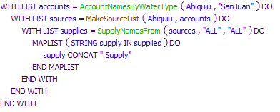

Referenced Functions

* RPL Object IconSupplyNamesFrom
* RPL Object IconAccountNamesByWaterType
* RPL Object IconMakeSourceList

### Control Display Icon1.3 RPL Object IconAllSJSuppliesFromElVado

**Return Type:** LIST

**Arguments:** None

Body

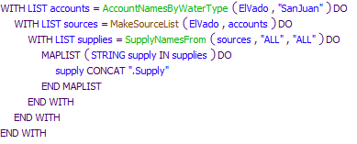

Referenced Functions

* RPL Object IconSupplyNamesFrom
* RPL Object IconAccountNamesByWaterType
* RPL Object IconMakeSourceList

### Control Display Icon1.4 RPL Object IconContractorSuppliesIntoReservoir

**Return Type:** LIST

**Arguments:**

* OBJECT reservoir
* STRING account

Body

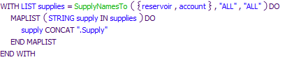

Referenced Functions

* RPL Object IconSupplyNamesTo

### Control Display Icon1.5 RPL Object IconContractorSuppliesFromReservoir

**Return Type:** LIST

**Arguments:**

* OBJECT reservoir
* STRING account

Body

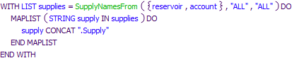

Referenced Functions

* RPL Object IconSupplyNamesFrom

## Control Display Icon2 RPL Object IconAccount Summing Functions

### Control Display Icon2.1 RPL Object IconSumAccountStorageAtGivenDate

**Return Type:** NUMERIC

**Arguments:**

* OBJECT reservoir
* LIST accounts
* DATETIME date

Body

Body

Referenced Functions

* RPL Object IconSum
* RPL Object IconAccountStorageAtGivenDate

### Control Display Icon2.2 RPL Object IconSumAccountStorage

**Return Type:** NUMERIC

**Arguments:**

* OBJECT reservoir
* LIST accounts

Body

Body

Referenced Functions

* RPL Object IconSum
* RPL Object IconPreviousAccountStorage

### Control Display Icon2.3 RPL Object IconSumSupplies

**Return Type:** NUMERIC

**Arguments:**

* LIST supplies

Body

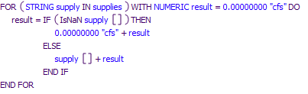

### Control Display Icon2.4 RPL Object IconSumSuppliesAtPreviousTimestep

**Return Type:** NUMERIC

**Arguments:**

* LIST supplies

Body

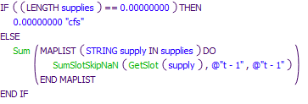

Referenced Functions

* RPL Object IconSumSlotSkipNaN
* RPL Object IconSum
* RPL Object IconGetSlot

### Control Display Icon2.5 RPL Object IconSumSuppliesSlot

**Return Type:** NUMERIC

**Arguments:**

* LIST supplies

Body

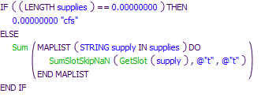

Referenced Functions

* RPL Object IconSumSlotSkipNaN
* RPL Object IconSum
* RPL Object IconGetSlot

## Control Display Icon3 RPL Object IconDate Functions

### Control Display Icon3.1 RPL Object IconStartOfMonthOrRun

**Return Type:** DATETIME

**Arguments:** None

Body

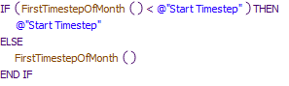

Referenced Functions

* RPL Object IconFirstTimestepOfMonth

### Control Display Icon3.2 RPL Object IconEndOfPreviousMonth

**Return Type:** DATETIME

**Arguments:** None

Body

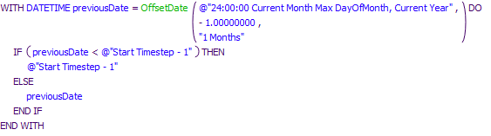

Referenced Functions

* RPL Object IconOffsetDate

### Control Display Icon3.3 RPL Object IconDateOfStartRow

**Return Type:** DATETIME

**Arguments:**

* SLOT slot

Body

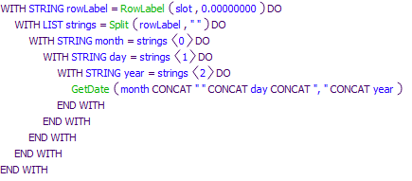

Referenced Functions

* RPL Object IconGetDate
* RPL Object IconRowLabel
* RPL Object IconSplit

### Control Display Icon3.4 RPL Object IconRowOfGivenDateInTableSeries

**Return Type:** NUMERIC

**Arguments:**

* SLOT slot
* DATETIME date

Body

Body

Referenced Functions

* RPL Object IconGetRowIndexByDate

### Control Display Icon3.5 RPL Object IconAbbreviateMonth

**Return Type:** STRING

**Arguments:**

* STRING month

Body

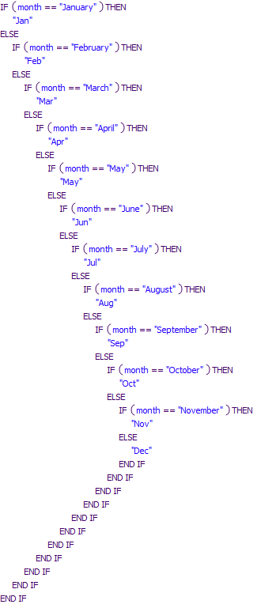

### Control Display Icon3.6 RPL Object IconAdd0ToDay

**Return Type:** STRING

**Arguments:**

* STRING day

Body

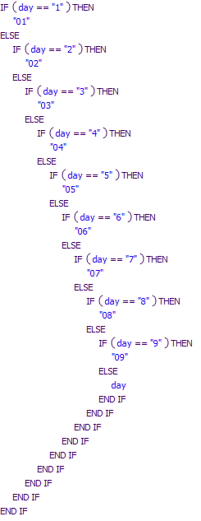

### Control Display Icon3.7 RPL Object IconGetStartDate

**Return Type:** DATETIME

**Arguments:** None

Body

Body

Referenced Functions

* RPL Object IconNumberToDate

### Control Display Icon3.8 RPL Object IconDatePlusTime

**Return Type:** DATETIME

**Arguments:**

* DATETIME date
* NUMERIC time

Body

Body

Referenced Functions

* RPL Object IconDateMin

### Control Display Icon3.9 RPL Object IconEndOfPrevYear

Returns December 31, 24:00:00 for the previous year.

**Return Type:** DATETIME

**Arguments:** None

Body

Body

Referenced Functions

* RPL Object IconCompletePartialDate

### Control Display Icon3.10 RPL Object IconFirstTimestepOfMonth

JR 8/8/2014:  
Adds the timestep length (in seconds) to the number of accumulated seconds from the reference point as the end of the previous month. Built to help generalize the rules for daily or monthly timesteps.

**Return Type:** DATETIME

**Arguments:** None

Body

Body

Referenced Functions

* RPL Object IconGetTimestep
* RPL Object IconEndOfPreviousMonth

### Control Display Icon3.11 RPL Object IconIsFirstTimestepOfMonth

**Return Type:** BOOLEAN

**Arguments:** None

Body

Body

Referenced Functions

* RPL Object IconGetMonth

### Control Display Icon3.12 RPL Object IconGetStartDate-1Timestep

**Return Type:** DATETIME

**Arguments:** None

Body

Body

Referenced Functions

* RPL Object IconNumberToDate
* RPL Object IconPreviousTimestep
* RPL Object IconRoundDateToTimestepEnd

### Control Display Icon3.13 RPL Object IconPreviousTimestep

**Return Type:** DATETIME

**Arguments:**

* DATETIME date

Body

Body

Referenced Functions

* RPL Object IconDateToNumber
* RPL Object IconNumberToDate
* RPL Object IconGetTimestep

## Control Display Icon4 RPL Object IconGeneral Account Functions

### Control Display Icon4.1 RPL Object IconAccountStorageAtGivenDate

**Return Type:** NUMERIC

**Arguments:**

* STRING account
* OBJECT reservoir
* DATETIME date

Body

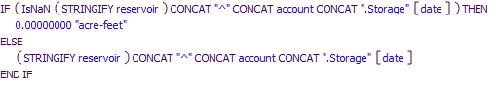

### Control Display Icon4.2 RPL Object IconPreviousAccountStorage

**Return Type:** NUMERIC

**Arguments:**

* STRING account
* OBJECT reservoir

Body

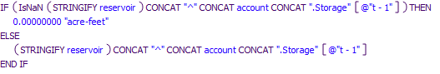

## Control Display Icon5 RPL Object IconGeneral Boolean Functions

### Control Display Icon5.1 RPL Object IconNaNInSlot

**Return Type:** BOOLEAN

**Arguments:**

* SLOT slot
* DATETIME startDate
* DATETIME endDate

Body

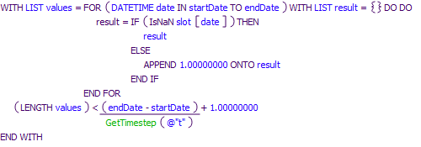

Referenced Functions

* RPL Object IconGetTimestep

### Control Display Icon5.2 RPL Object IconNaNInTableSeriesSlot

**Return Type:** BOOLEAN

**Arguments:**

* SLOT slot
* DATETIME startDate
* DATETIME endDate
* STRING column

Body

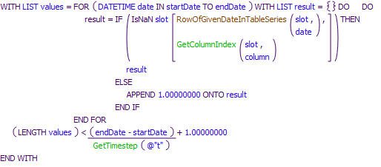

Referenced Functions

* RPL Object IconGetColumnIndex
* RPL Object IconGetTimestep
* RPL Object IconRowOfGivenDateInTableSeries

### Control Display Icon5.3 RPL Object IconIsIterativeRun

**Return Type:** BOOLEAN

**Arguments:** None

Body

Body

### Control Display Icon5.4 RPL Object IconIsAOPModelRun

**Return Type:** BOOLEAN

**Arguments:** None

Body

Body

### Control Display Icon5.5 RPL Object IconIsAccountModelRun

**Return Type:** BOOLEAN

**Arguments:** None

Body

Body

### Control Display Icon5.6 RPL Object IconIsHistoricalModelRun

**Return Type:** BOOLEAN

**Arguments:** None

Body

Body

### Control Display Icon5.7 RPL Object IconIsIrrigationSeasonCO

**Return Type:** BOOLEAN

**Arguments:** None

Body

Body

### Control Display Icon5.8 RPL Object IconIsFirstTimestepCOIrrigationSeason

12/18/17 JR: Created to allow compact curtailment calculations to occur the day before irrigation season to avoid timestep delay in the allocatable supply chain availability on the first timestep of irrigation season. No big deal for daily timestep, but big deal for monthly.

**Return Type:** BOOLEAN

**Arguments:**

* DATETIME time

Body

Body

Referenced Functions

* RPL Object IconCompletePartialDate
* RPL Object IconRoundDateToTimestepEnd

## Control Display Icon6 RPL Object IconGet Data Functions

### Control Display Icon6.1 RPL Object IconRoundingFactorVolume

**Return Type:** NUMERIC

**Arguments:**

* NUMERIC volume

Body

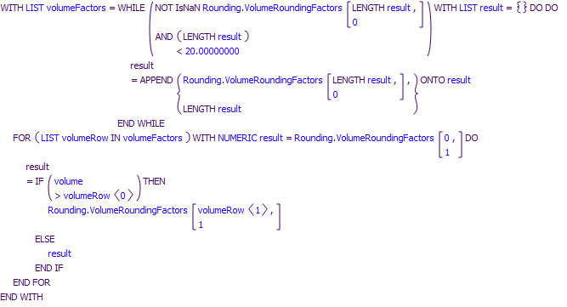

### Control Display Icon6.2 RPL Object IconRoundVolume

**Return Type:** NUMERIC

**Arguments:**

* NUMERIC number

Body

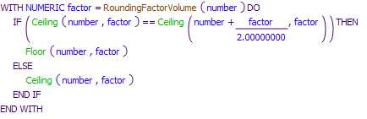

Referenced Functions

* RPL Object IconCeiling
* RPL Object IconFloor
* RPL Object IconRoundingFactorVolume

### Control Display Icon6.3 RPL Object IconCurrentStorage

**Return Type:** NUMERIC

**Arguments:**

* OBJECT reservoir

Body

Body

### Control Display Icon6.4 RPL Object IconSJCLoss

**Return Type:** NUMERIC

**Arguments:**

* OBJECT fromReservoir
* OBJECT toReservoir

Body

Body

### Control Display Icon6.5 RPL Object IconPreviousStorage

**Return Type:** NUMERIC

**Arguments:**

* OBJECT reservoir

Body

Body

### Control Display Icon6.6 RPL Object IconHydrologyYearType

**Return Type:** STRING

**Arguments:** None

Body

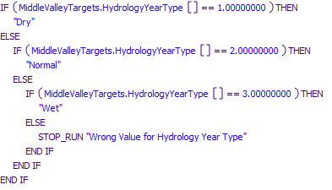

### Control Display Icon6.7 RPL Object IconGetTableDate

**Return Type:** DATETIME

**Arguments:**

* SLOT slot
* STRING row
* STRING col

Body

Body

Referenced Functions

* RPL Object IconNumberToDate
* RPL Object IconNextDate

### Control Display Icon6.8 RPL Object IconIceMonths

**Return Type:** BOOLEAN

**Arguments:** None

Body

Body

### Control Display Icon6.9 RPL Object IconGetNRCSForecast

**Return Type:** NUMERIC

**Arguments:** None

Body

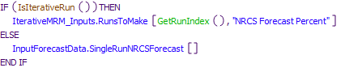

Referenced Functions

* RPL Object IconGetRunIndex
* RPL Object IconIsIterativeRun

### Control Display Icon6.10 RPL Object IconGetWholeNumberAsString

**Return Type:** STRING

**Arguments:**

* NUMERIC number

Body

Body

Referenced Functions

* RPL Object IconSplit

### Control Display Icon6.11 RPL Object IconGetMRGCDDiversionRequested

**Return Type:** NUMERIC

**Arguments:**

* OBJECT middleRioGrandeCanal
* DATETIME date

Body

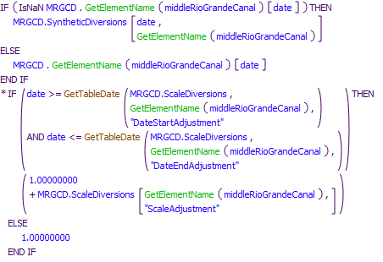

Referenced Functions

* RPL Object IconGetElementName
* RPL Object IconGetTableDate

### Control Display Icon6.12 RPL Object IconMinTargetFlowWithoutSafetyFactor

**Return Type:** NUMERIC

**Arguments:**

* STRING location
* DATETIME date
* NUMERIC time

Body

Body

Referenced Functions

* RPL Object IconHydrologyYearType
* RPL Object IconDatePlusNTimesteps
* RPL Object IconRoundDurationToTimestep

### Control Display Icon6.13 RPL Object IconRound

**Return Type:** NUMERIC

**Arguments:**

* NUMERIC number
* NUMERIC factor

Body

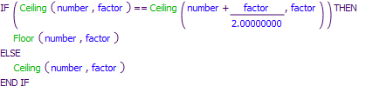

Referenced Functions

* RPL Object IconCeiling
* RPL Object IconFloor

## Control Display Icon7 RPL Object IconSumming Functions

### Control Display Icon7.1 RPL Object IconSumTableSeriesSlotByColumn

**Return Type:** NUMERIC

**Arguments:**

* SLOT slot
* DATETIME startDate
* DATETIME endDate
* STRING column

Body

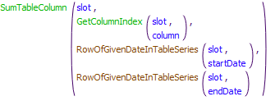

Referenced Functions

* RPL Object IconSumTableColumn
* RPL Object IconGetColumnIndex
* RPL Object IconRowOfGivenDateInTableSeries

### Control Display Icon7.2 RPL Object IconSumDiversionReachDepletionsToVolume

**Return Type:** NUMERIC

**Arguments:**

* STRING subbasin
* STRING gage

Body

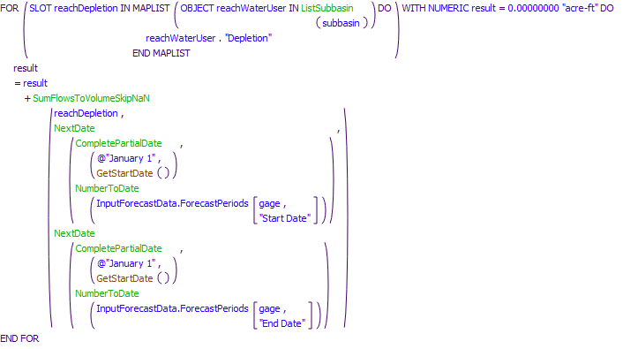

Referenced Functions

* RPL Object IconListSubbasin
* RPL Object IconSumFlowsToVolumeSkipNaN
* RPL Object IconCompletePartialDate
* RPL Object IconNumberToDate
* RPL Object IconNextDate
* RPL Object IconGetStartDate

## Control Display Icon8 RPL Object IconTimestepFunctions

Functions created to generalize from daily timestep ruleset to daily or monthly, that don't conceptually fit anywhere else.

### Control Display Icon8.1 RPL Object IconDatePlusNTimesteps

JR 9/8/15: Old function DatePlusXTimesteps was renamed to DatePlusTime because it didn't take # timesteps as an argument, it took a time span. This function was written to return the date associated with an input date and a number of timesteps. Used N to avoid possibly confusion and mistakes with the previous function.

**Return Type:** DATETIME

**Arguments:**

* DATETIME date
* NUMERIC timesteps

Body

Body

Referenced Functions

* RPL Object IconDateMin
* RPL Object IconGetTimestep

### Control Display Icon8.2 RPL Object IconFirstTimestepOfYear

**Return Type:** DATETIME

**Arguments:** None

Body

Body

Referenced Functions

* RPL Object IconRoundDateToTimestepEnd

### Control Display Icon8.3 RPL Object IconIsFirstTimestepOfYear

Designed to return TRUE if the model timestep is the first timestep of the year. Allows rules that formelry checked if the date was 24:00 Jan 1st to work for daily or monthly, or other timesteps.

**Return Type:** BOOLEAN

**Arguments:** None

Body

Body

Referenced Functions

* RPL Object IconGetYear

### Control Display Icon8.4 RPL Object IconRoundDateToTimestepEnd

For any FullDateTime, this function will return the FullDateTime associated with the timestep of the input FullDateTime. Written for daily and monthly timesteps supported in URGWOM only, but could be expanded for any RiverWare timestep length. Table below represents theoretical behavior of full function. Current simple version of the function will output the daily timestep result for all timesteps less than or equal to a day, and the monthly timestep result for all other timesteps.

Input Output Hourly Timestep Output Daily Timestep Output Monthly Timeste Output Annual Timestep  
16:45 1/3/15 17:00 1/3/15 24:00 1/3/15 24:00 1/31/15 24:00 12/31/15

**Return Type:** DATETIME

**Arguments:**

* DATETIME date

Body

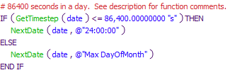

Referenced Functions

* RPL Object IconNextDate
* RPL Object IconGetTimestep

### Control Display Icon8.5 RPL Object IconRoundDurationToTimestep

JR 9/8/15: Function rounds a duration with units of time to the nearest number of timesteps represented by that duration. So a 1 day duration will round to 1 timestep for a daily model, and 0 timesteps for a monthly model.

**Return Type:** NUMERIC

**Arguments:**

* NUMERIC duration

Body

Body

Referenced Functions

* RPL Object IconGetTimestep
* RPL Object IconRound

## Control Display Icon9 RPL Object IconColoradoCompactFunctions

### Control Display Icon9.1 RPL Object IconConejosIndexFlowVolume

**Return Type:** NUMERIC

**Arguments:** None

Body

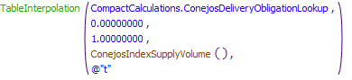

Referenced Functions

* RPL Object IconTableInterpolation
* RPL Object IconConejosIndexSupplyVolume

### Control Display Icon9.3 RPL Object IconRioGrandeIndexFlowVolume

**Return Type:** NUMERIC

**Arguments:** None

Body

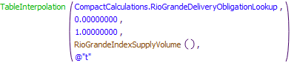

Referenced Functions

* RPL Object IconTableInterpolation
* RPL Object IconRioGrandeIndexSupplyVolume

### Control Display Icon9.3 RPL Object IconConejosIndexSupplyVolume

**Return Type:** NUMERIC

**Arguments:** None

Body

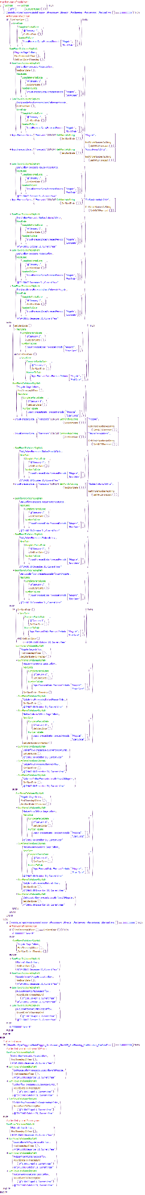

Referenced Functions

* RPL Object IconSumFlowsToVolumeSkipNaN
* RPL Object IconCompletePartialDate
* RPL Object IconNumberToDate
* RPL Object IconNextDate
* RPL Object IconGetMonthAsString
* RPL Object IconGetYear
* RPL Object IconRunStartDate
* RPL Object IconGetStartDate-1Timestep
* RPL Object IconGetNRCSForecast
* RPL Object IconRoundDateToTimestepEnd
* RPL Object IconGetStartDate
* RPL Object IconFirstTimestepOfYear
* RPL Object IconGetWholeNumberAsString

### Control Display Icon9.4 RPL Object IconRioGrandeIndexSupplyVolume

**Return Type:** NUMERIC

**Arguments:** None

Body

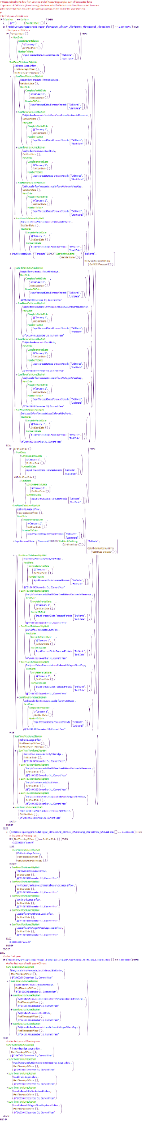

Referenced Functions

* RPL Object IconSumFlowsToVolumeSkipNaN
* RPL Object IconCompletePartialDate
* RPL Object IconNumberToDate
* RPL Object IconNextDate
* RPL Object IconGetMonthAsString
* RPL Object IconGetYear
* RPL Object IconRunStartDate
* RPL Object IconGetStartDate-1Timestep
* RPL Object IconGetNRCSForecast
* RPL Object IconGetStartDate
* RPL Object IconFirstTimestepOfYear
* RPL Object IconGetWholeNumberAsString